AION Runbook

4/14/2023

The purpose of this runbook is to document frequently used fixes for user issues.

# User Can’t Log In – Insufficient Permissions

Search in the database for user email – src_system_val_txt, email_addr_txt, user_nm;

Go to AION and check the users found to see what roles they have

1. Not in the user table – add user in AION,
2. Not in AD group or Azure AD group - add user in AD or Azure AD depending on which you need. 894760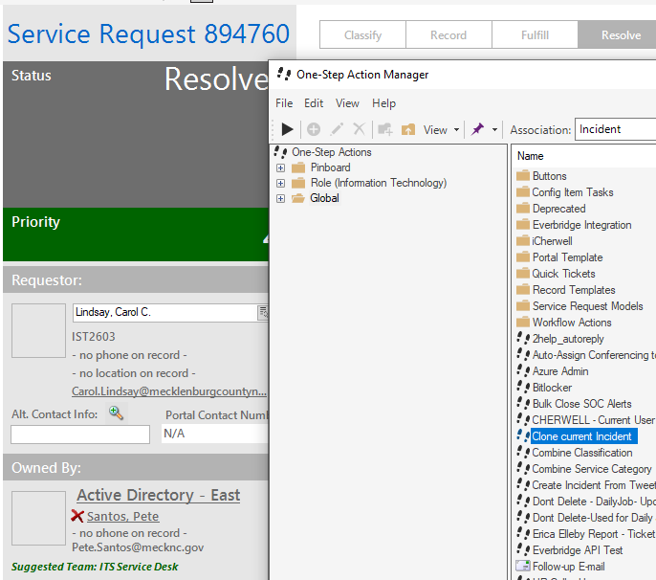
3. Check if user is active in AION Admin
4. Check roles in AION Admin
5. Check User Permissions – if everything is unchecked, they may not be able to log in

# New Project Manager Email Request

Clone previous new project manager request in Cherwell. Update Name and Email. Project managers are customers and are always added as external.

User must have a “real” first name and last name with more than one character.

Assign to Active Directory – East. Do not assign to a specific person.



# MS Graph Integration

## Creating/Updating a User in AION

**If a user record has the CITY_IND flag set to true:**

The user principal email address is set to [permitplanreview@mecklenburgcountync.gov](mailto:permitplanreview@mecklenburgcountync.gov).

When updating a user in the UserAdapter.UpdateUser method, the user’s Outlook data is retrieved at UserAdapter.GetOutlookDataForUser. If the user is a city user and the principal email address is set to [permitplanreview@mecklenburgcountync.gov](mailto:permitplanreview@mecklenburgcountync.gov), MS Graph is queried to see if there is already a calendar created with the email address of the user. If one doesn’t already exist, it gets created and the method will return the unique calendar id.

The user’s principal name is saved as permitplanreview@mecklengburgcountync.gov.

The user’s calendar id is saved as the one returned by the call to the API.

**If a user record has the CITY_IND flag set to false:**

MS Graph API is first queried to obtain the user principal name by email address.

MS Graph API is next queried to obtain the *default* calendar id for that user’s principal name.

## Scheduling a Calendar Event

**A calendar event record gets created for the calendar event queue record. The object is the CalendarEventBE:**

public int? CalendarEventQueueId { get; set; }

public string JsonObjectTxt { get; set; } (OutlookCalendarAppointment object)

public string ActionDesc { get; set; } (“Create” or “Delete”)

public bool? ProcessedInd { get; set; }

public DateTime? ProcessedDate { get; set; }

public bool? InProcessInd { get; set; }

public DateTime? InProcessDate { get; set; }

The **JsonObjectTxt** is serialized based on the **OutlookCalendarAppointment** object:

public Event Event { get; set; } (Microsoft.Graph.Event object)

public DateTime StartDate { get; set; }

public DateTime EndDate { get; set; }

public List<UserOutlookDetail> UserOutlookDetails { get; set; } (UserOutlookDetail)

The **UserOutlookDetail** object:

public string UserPrincipalName { get; set; }

public string CalendarId { get; set; }

public bool IsProcessed { get; set; }

Two separate function app processes run against the CALENDAR_EVENT_QUEUE table:

ProcessCalendarEventQueueForNotProcessedItems

ProcessCalendarEventQueueForInProcessItems

## City User View of Calendar

Once the city user’s calendar has been created and published, the corresponding .ics file needs to be shared to the city user so they can add the calendar to their Outlook login.

First, an AION development team member needs to access the public login for Permit Plan Review:

<https://outlook.office365.com/calendar/view/month>

From the gear icon in the top right corner, access the settings and then ‘View all Outlook Settings’:

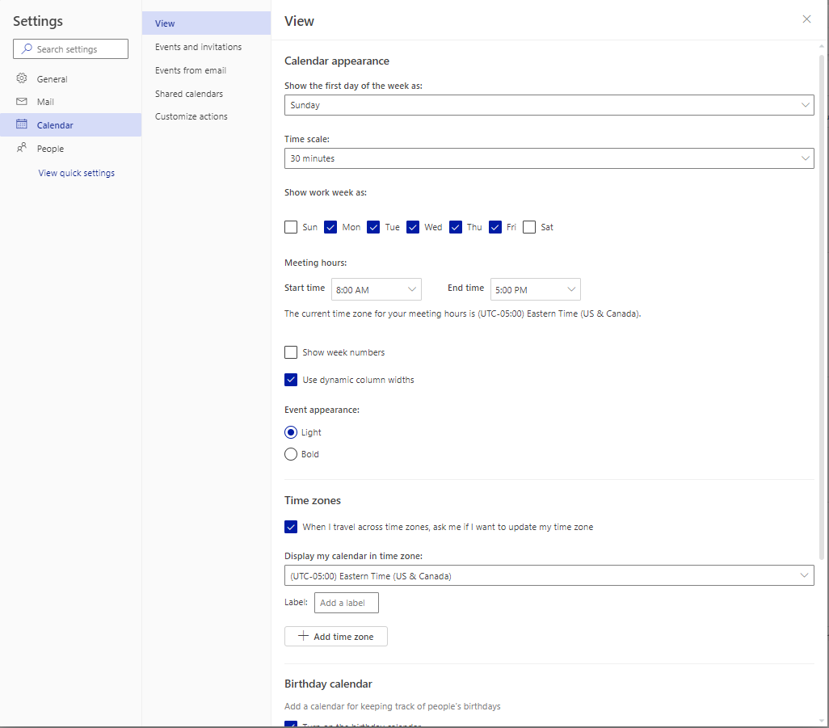

Click on Shared calendars and select the city user’s calendar under ‘Publish a Calendar’.

Grab the .ics file link and share/send this link to the new city user.

Within the user’s Outlook application, this is the navigation, Other Calendars => Add Calendar => From Internet => paste the .ics link here and select ‘OK’

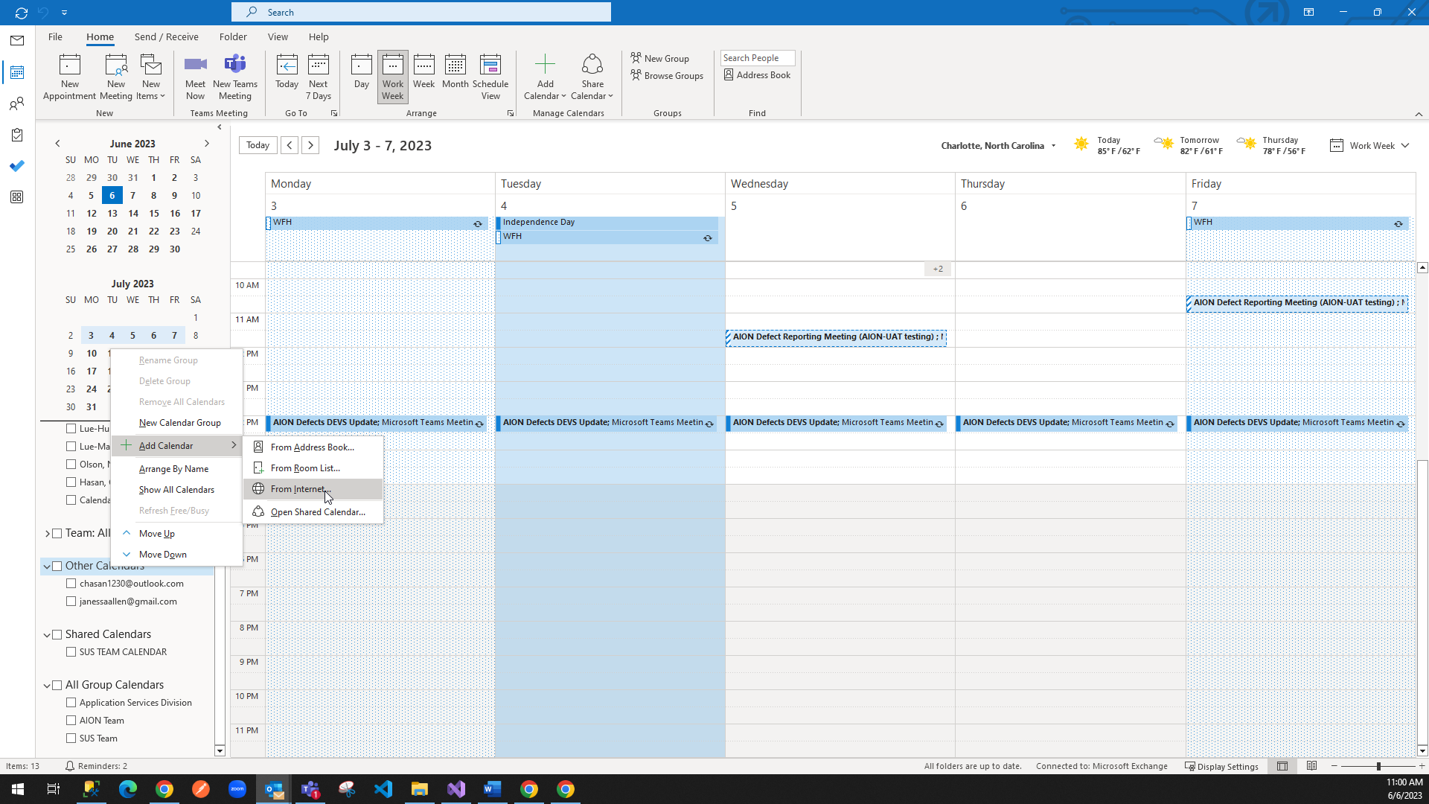

## Publish a Calendar

First, an AION development team member needs to access the public login for Permit Plan Review:

<https://outlook.office365.com/calendar/view/month>

From the gear icon in the top right corner, access the settings and then ‘View all Outlook Settings’

Click on Shared Calendars.

Select User from dropdown under the Publish a calendar heading.

Select Can view all details in Permission dropdown.

Click Publish.

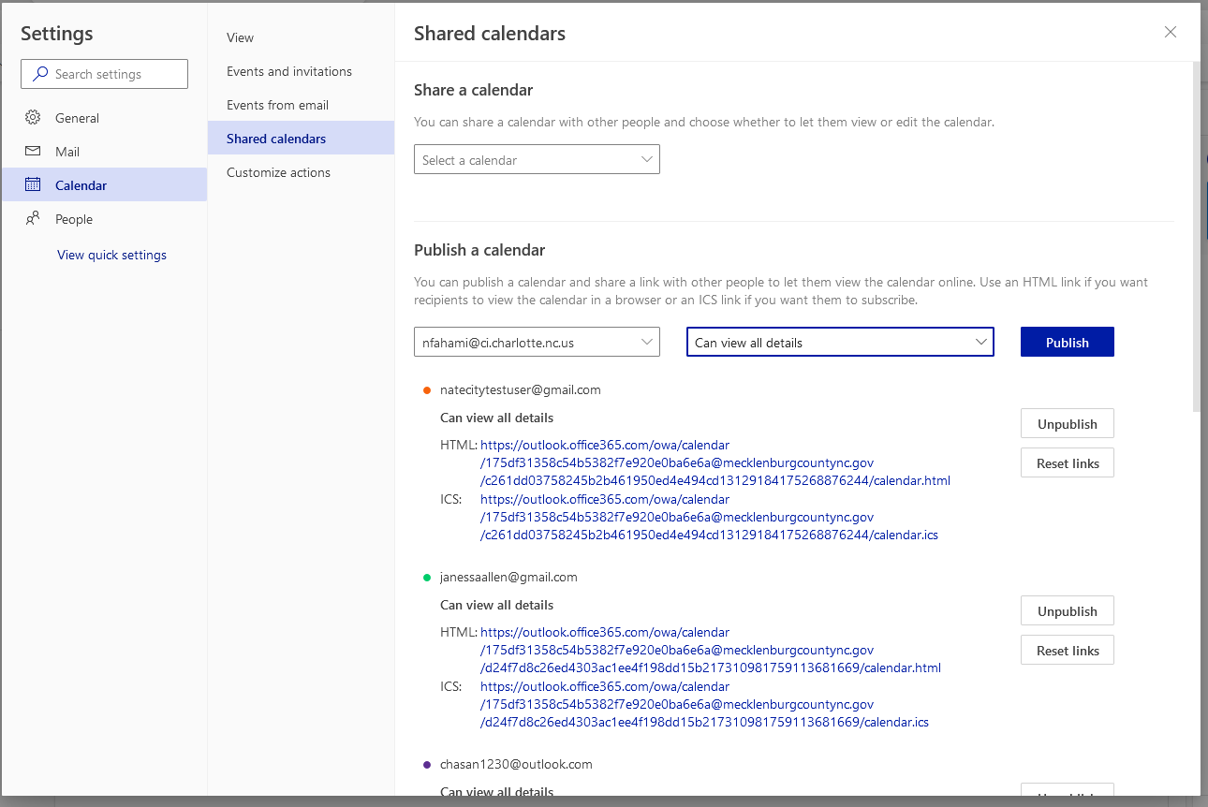

# Remediate Bug for FIFO Duplicate Plans Received

Until we can address this bug, this needs to be the AION fix to back out the second cycle created when the gate is rejected in Accela and another set of plans are uploaded:

For the PROJECT_ID in AION:

DELETE FROM PROJECT_CYCLE WHERE PROJECT_ID = @PROJECT_ID AND CYCLE_NBR = 2

UPDATE PROJECT_CYCLE SET CYCLE_NBR = 1, CURRENT_CYCLE_IND = 1, IS_COMPLETE_IND = 0 WHERE CYCLE_NBR = 1

UPDATE PROJECT SET PROJECT_STATUS_REF_ID = 3, CYCLE_NBR = 1 WHERE PROJECT_ID = @PROJECT_ID

# Reset a Project Back to An Earlier Cycle

Users may have advanced a project through the AION process and realize that a mistake has been made and, therefore, would like to reset the project back to a cycle one status. There is a stored procedure that can be executed for a project to be reverted to an earlier/previous cycle status.

An example of the call to execute this procedure would be:

**EXEC usp_update_aion_project_cycle_reset ‘R-SF-00004’, 1**

Where the first parameter is the project number of the project to be reset and the second parameter is the cycle number to set it back to.